Faculty Development Programme at IFLU
This report provides an evaluation of the English training class conducted at the International Foreign Language University (IFLU) Hyderabad. These classes aimed to enhance the English language skills of participants, focusing on reading, writing, speaking, and listening. This training is significant for students of UG all over the state, as it prepares them for global communication and further academic pursuits.

Course Structure and Overview
The English training class took place over a period of one week with sessions held from 10.00 am to 4.15 pm.
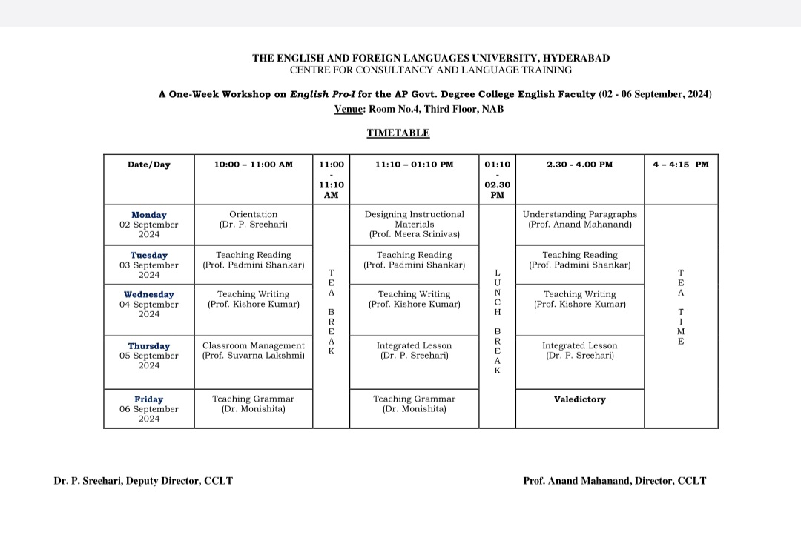

Teaching Methods
Various teaching methods were employed, including:
- Interactive lectures to introduce new concepts.
- Group discussions to encourage collaboration.
- Role-playing activities to enhance speaking and listening skills.
- Utilization of language learning apps and online resources to supplement traditional learning.

Participant Engagement
- Participants were highly engaged throughout the course. Group activities fostered an inclusive environment, and students actively contributed to discussions. Feedback indicated that many appreciated the interactive nature of the classes, which helped build their confidence in using English.

Outcomes and Achievements
By the end of the training class, participants demonstrated marked improvement in their language skills:
- Speaking Skills: Increased fluency and confidence during presentations.
- Writing Skills: Improved structure and clarity in written assignments.
- Listening Skills: Enhanced comprehension during discussions and lectures.
- Reading Skills: Enhanced Readinh Techniques

PHOTO GALLARY

